**Reviving the Soul of the Soil: Rabby’s Journey to Restoring Land and Hope in Sirajganj**

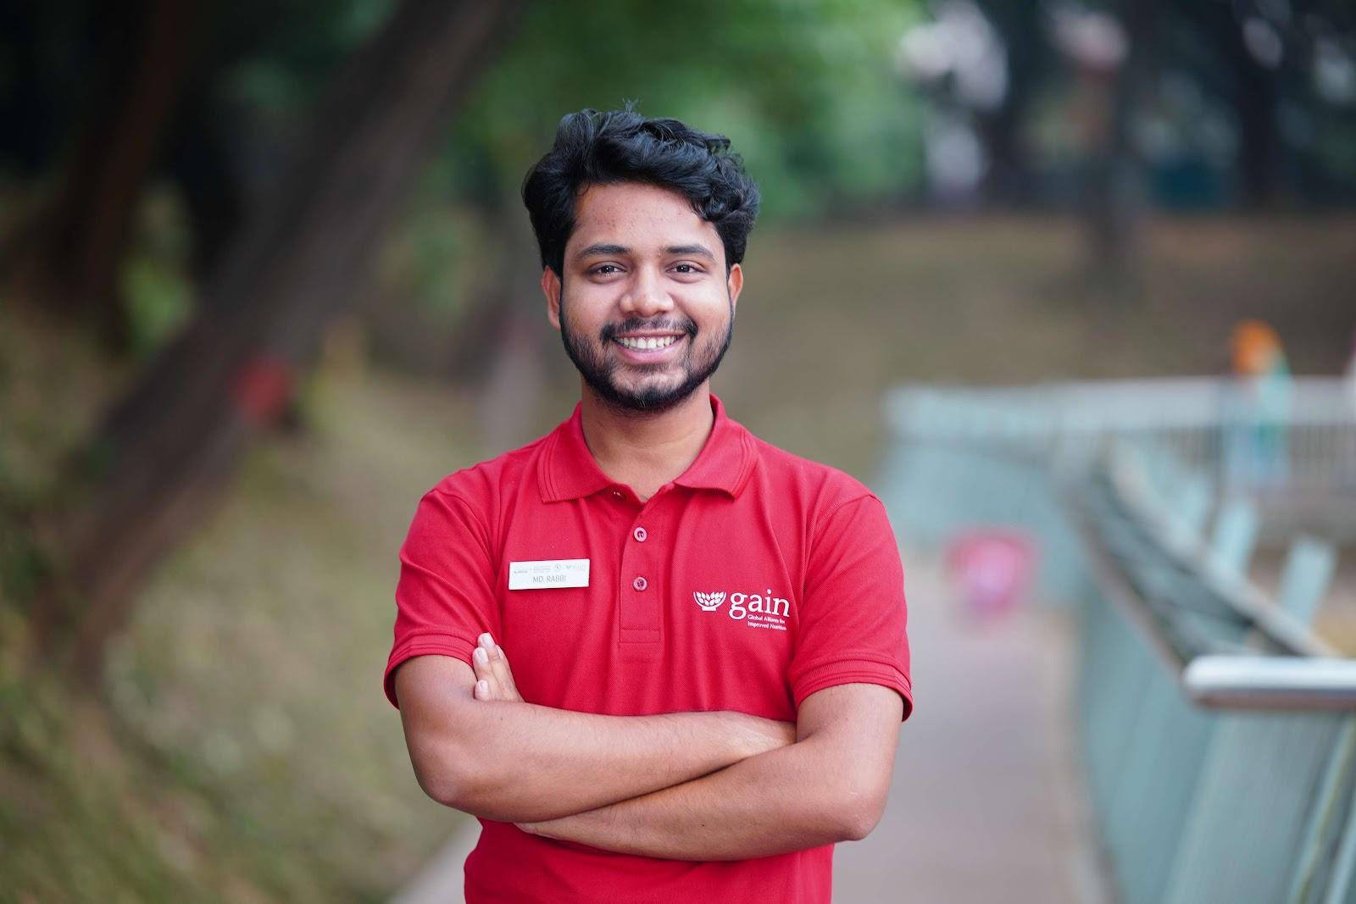

Rabby first learned about the Food Systems Youth Leadership Training of Trainers while scrolling on social media. The words “youth” and “leadership” caught his attention, and he registered out of curiosity. He did not expect it to change anything. Yet the training became a meaningful turning point in how he understood his role in the community.

Through sessions on food systems, Rabby began to view familiar problems differently. He realised that leadership does not always require a position or authority. It can start with noticing an issue and deciding to take responsible action. **“The training awakened the leader within me. I learned how to speak for justice at the decision-making table. This journey turned me from a dreamer into a doer,”** he said.

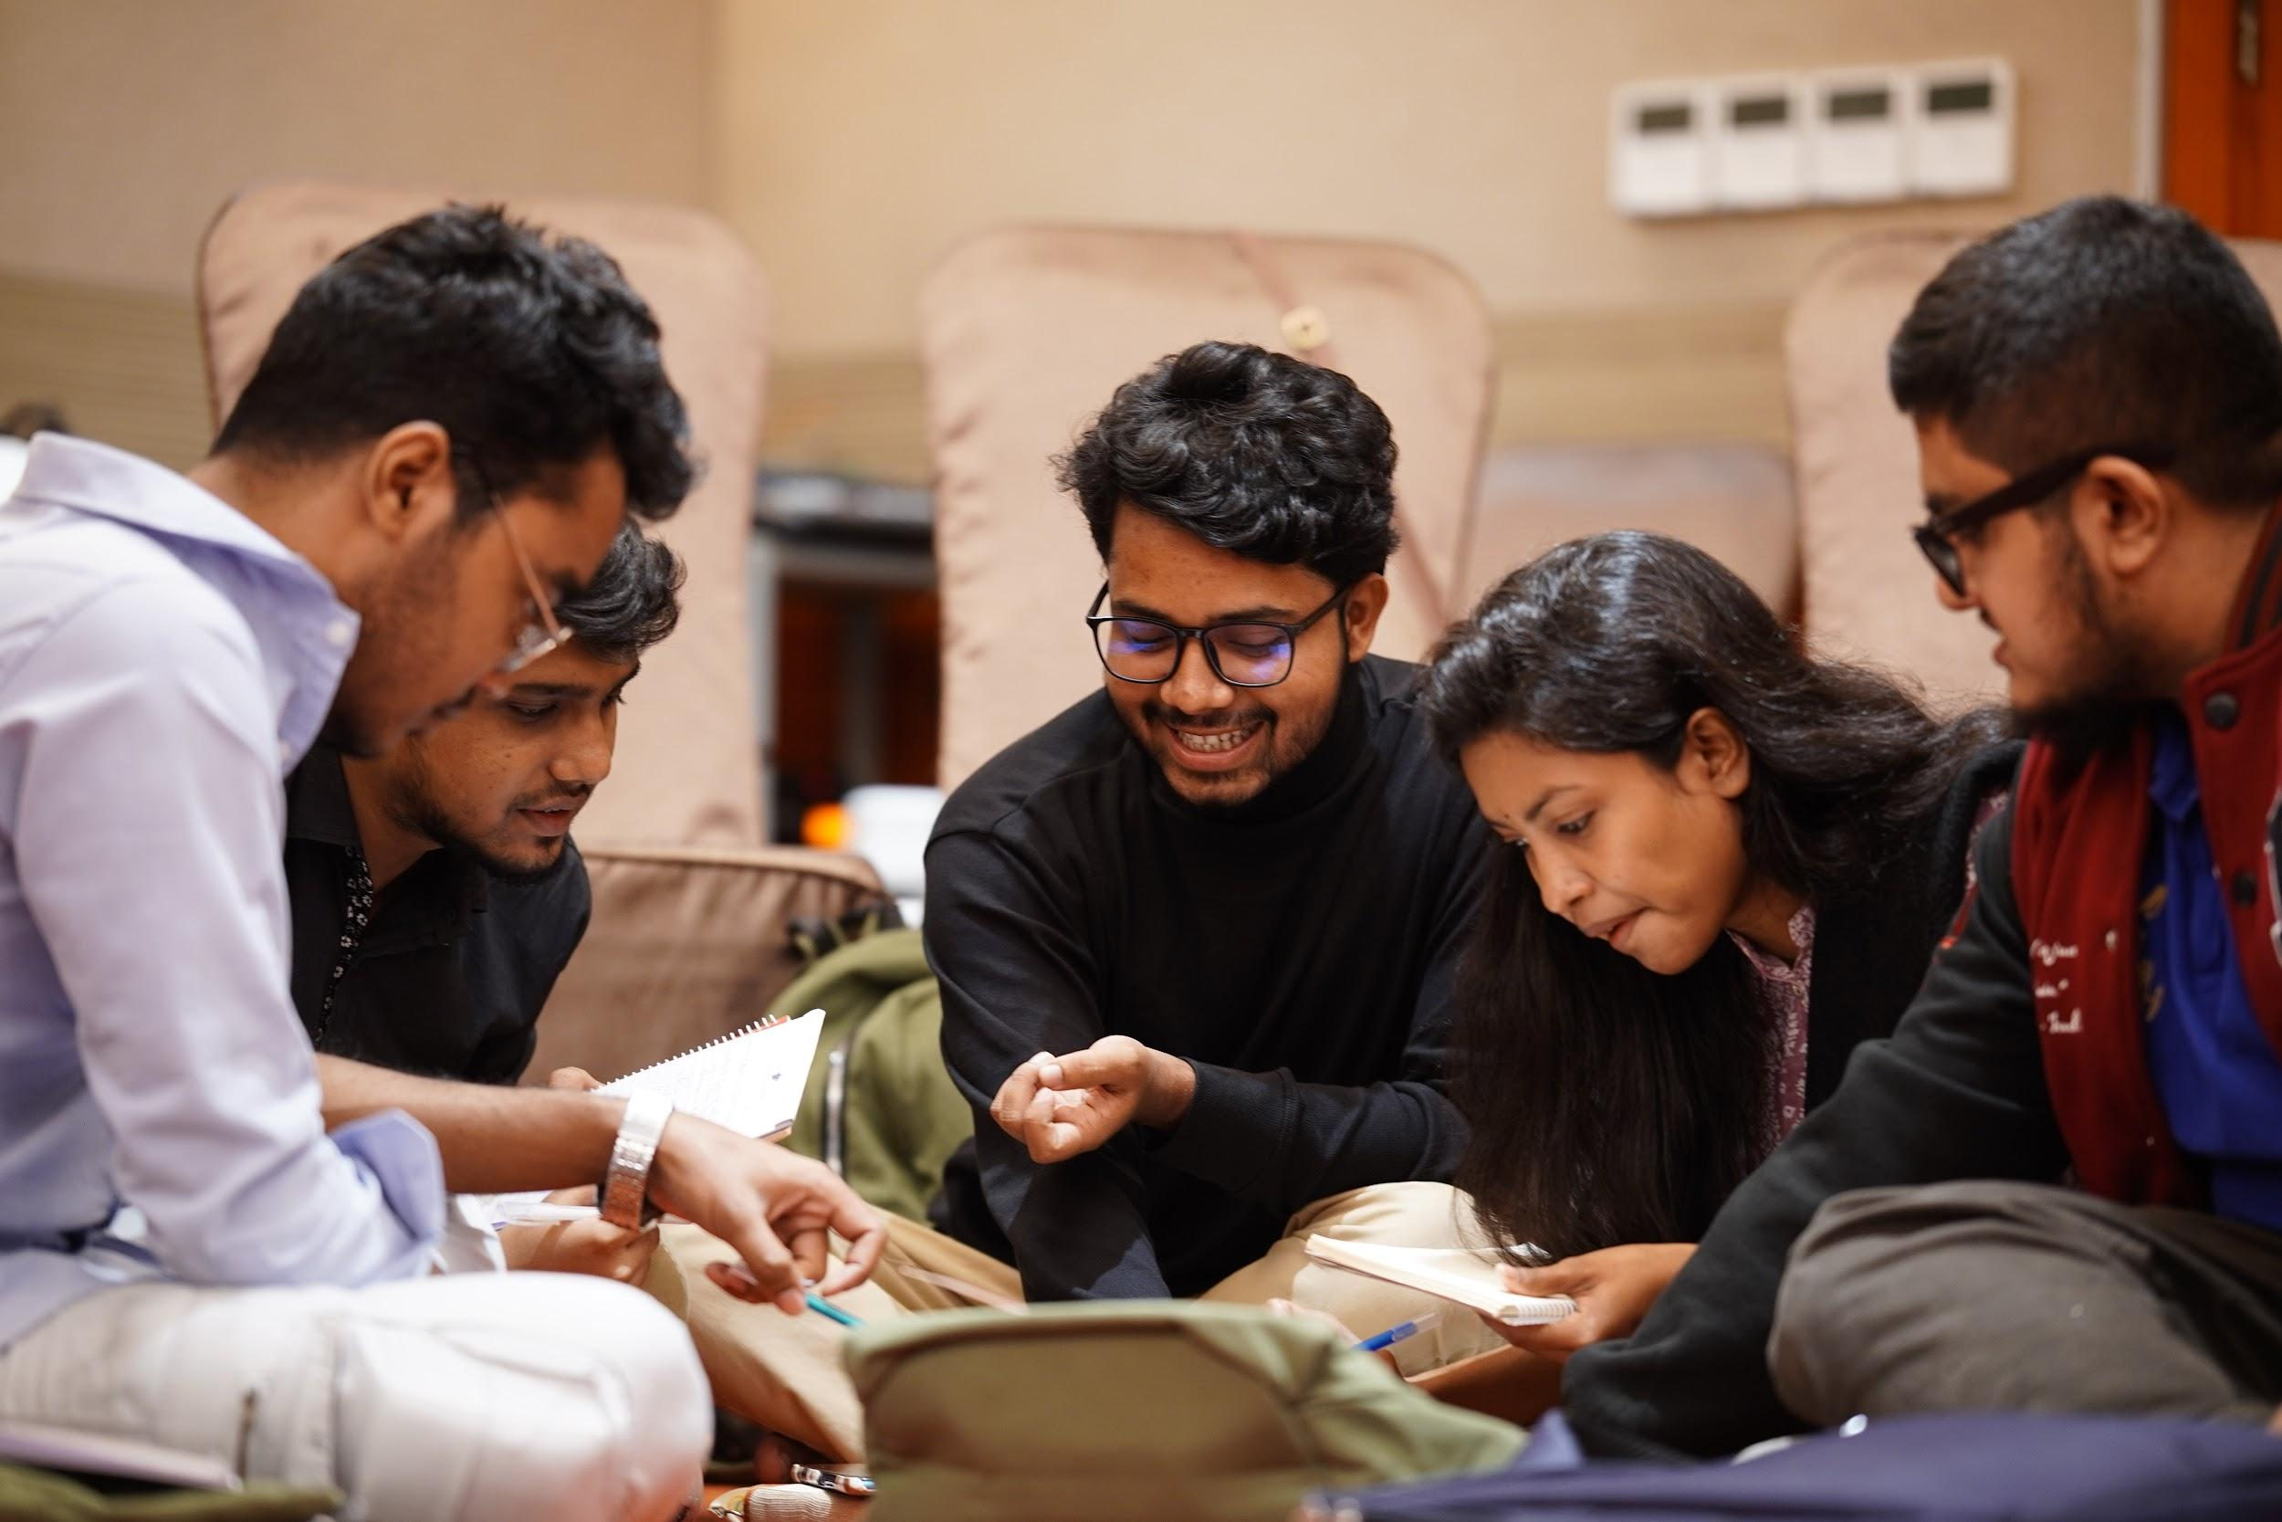

The lessons stayed with him when he returned to Kamarpara village in Sirajganj. Farmers there had been struggling for years. Heavy use of chemical fertilisers had weakened the soil. Where fields once yielded 20 to 25 maunds of paddy per acre, production had fallen to 10 to 15. Vegetables lacked colour, and seasonal crops were becoming harder to grow. Farmers tried using more chemicals, but the soil grew even weaker.

Rabby felt that change needed to come from within the community. So he started small. He sat with farmers, listened to their concerns and tried to understand what they hoped for. From these conversations, an idea took shape: a vermicomposting initiative he named “Turning the Soil Around with Earthworms.” The goal was simple. Use organic compost to bring life back to the soil.

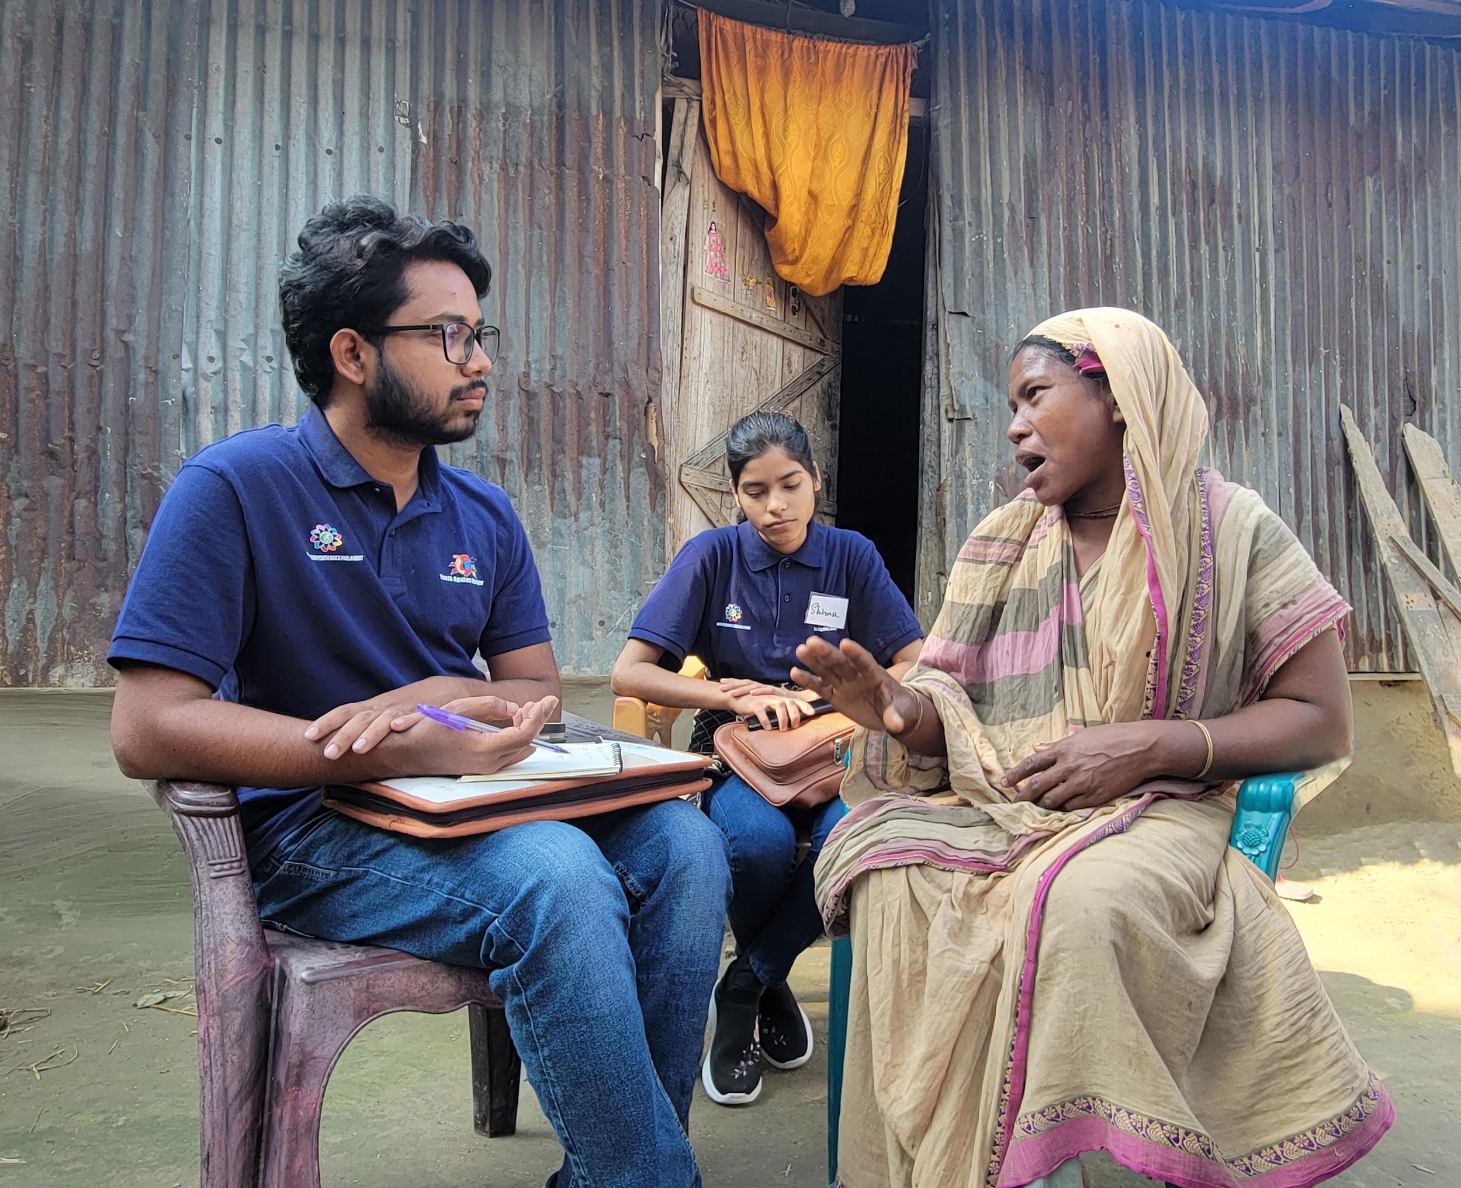

There was a time when frustration hung heavy in the air of Kamarpara village in Sirajganj. Years of chemical fertilizer use had stripped the soil of its fertility. Crop yields declined sharply where once farmers harvested 20–25 maunds of paddy per acre, it had dropped to just 10–15. Whether it was rice, vegetables, or seasonal produce, nothing was growing like before. Farmers responded with more chemicals, but the land grew only weaker. When Rabby returned home, he saw the same weary soil, the same worried farmers, and the same quiet despair. But he also realized something important, true change wouldn’t come from outside. It had to begin with the people. So, he began small. Sitting with farming families each day, he listened not just to their frustrations, but also to their dreams. And from those deep conversations, a new vision emerged: “Turning the Soil Around with Earthworms.” A vermicomposting initiative that would revive the land using organic compost and earthworms.

The beginning was far from easy. Some people doubted the idea. Others laughed at the thought of using earthworms to fix damaged land. Rabby had no funding and used his own savings for the first steps. Some local influencers refused to provide space for the project. Even so, he continued. Slowly, support started to grow. With encouragement from the Bangladesh Youth Mock Parliament and funding from GAIN, the project became possible. The support kept the initiative alive during its most difficult stages.

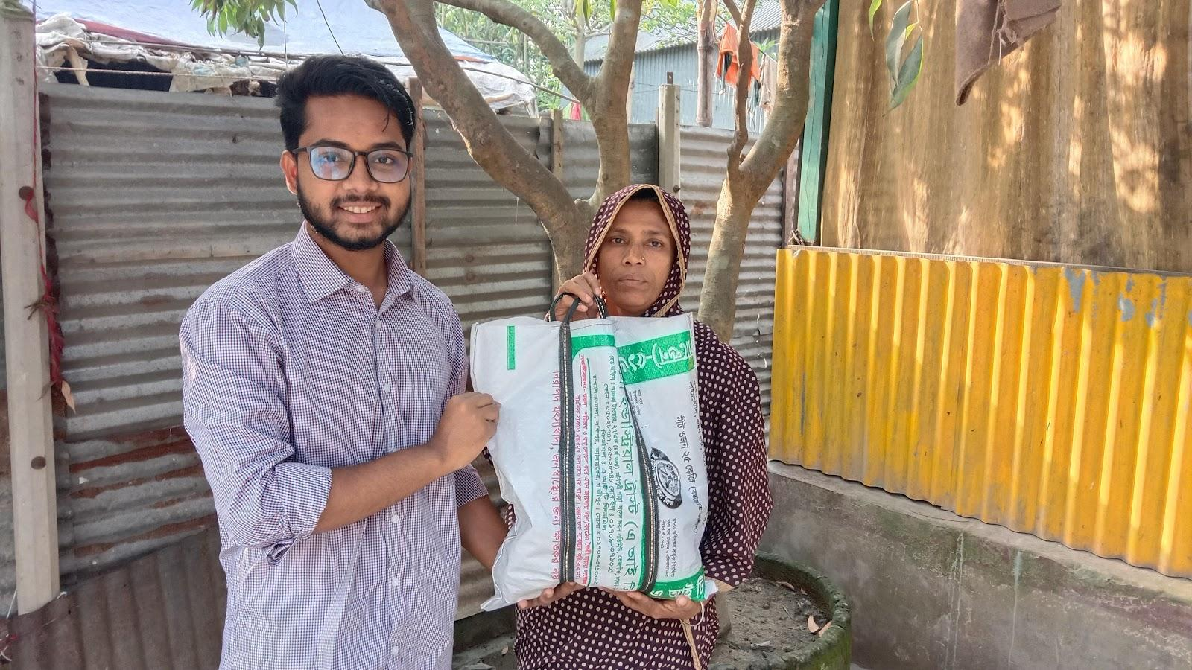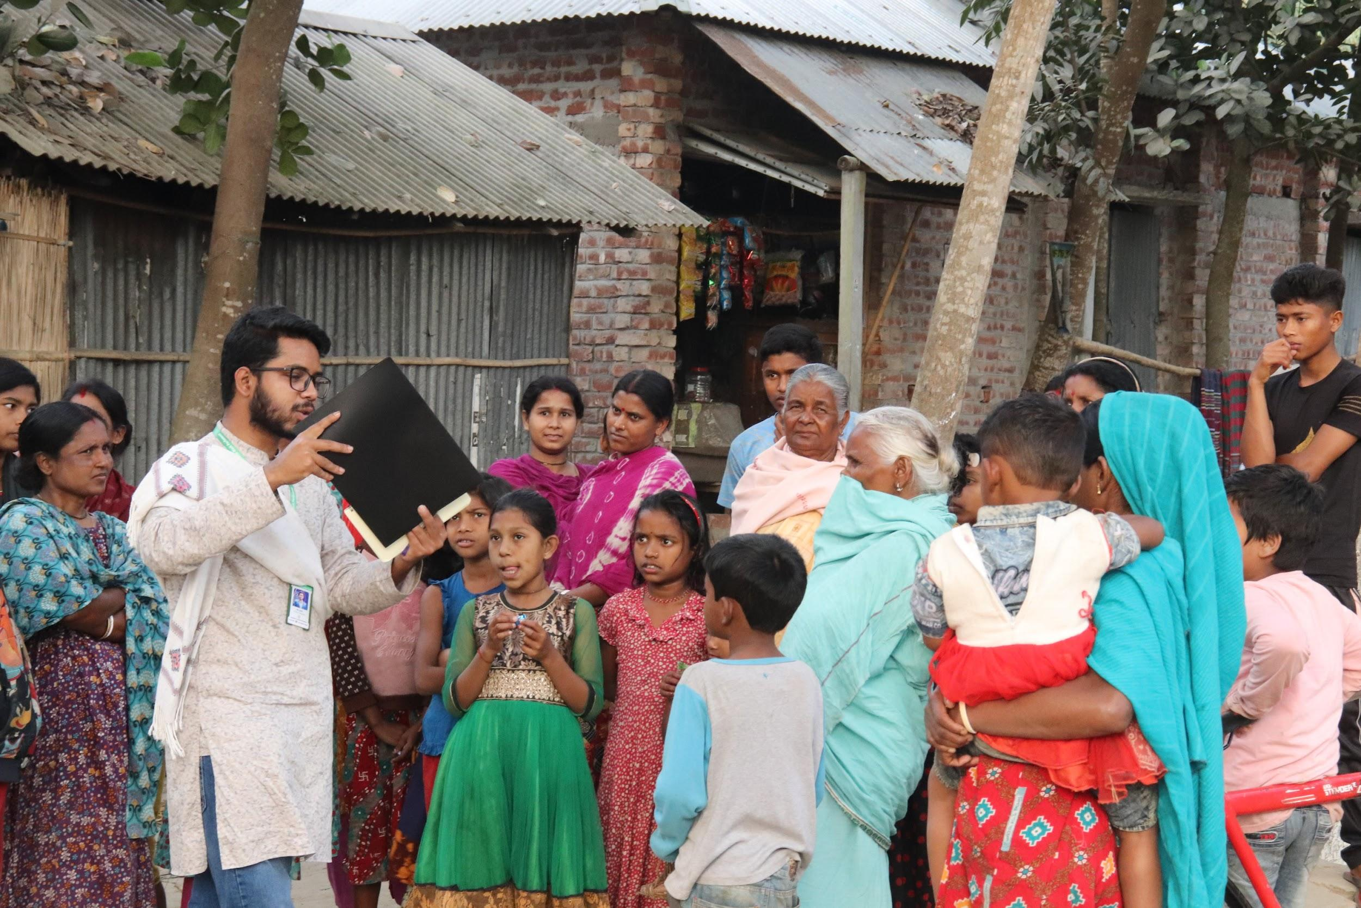

Thirteen young people eventually joined Rabby. They worked together to launch the vermicomposting effort, learning and experimenting as a team. Within two years, the impact became visible. The same land that had lost its strength was producing 20 to 25 maunds of rice per acre again. Farmers used no chemical fertilisers. Only organic compost. The soil responded with healthier crops and renewed fertility.

“**Farmers told me their yields rose noticeably after using my vermicompost**,” Rabby said. “**The tired soil is finally breathing again.”**

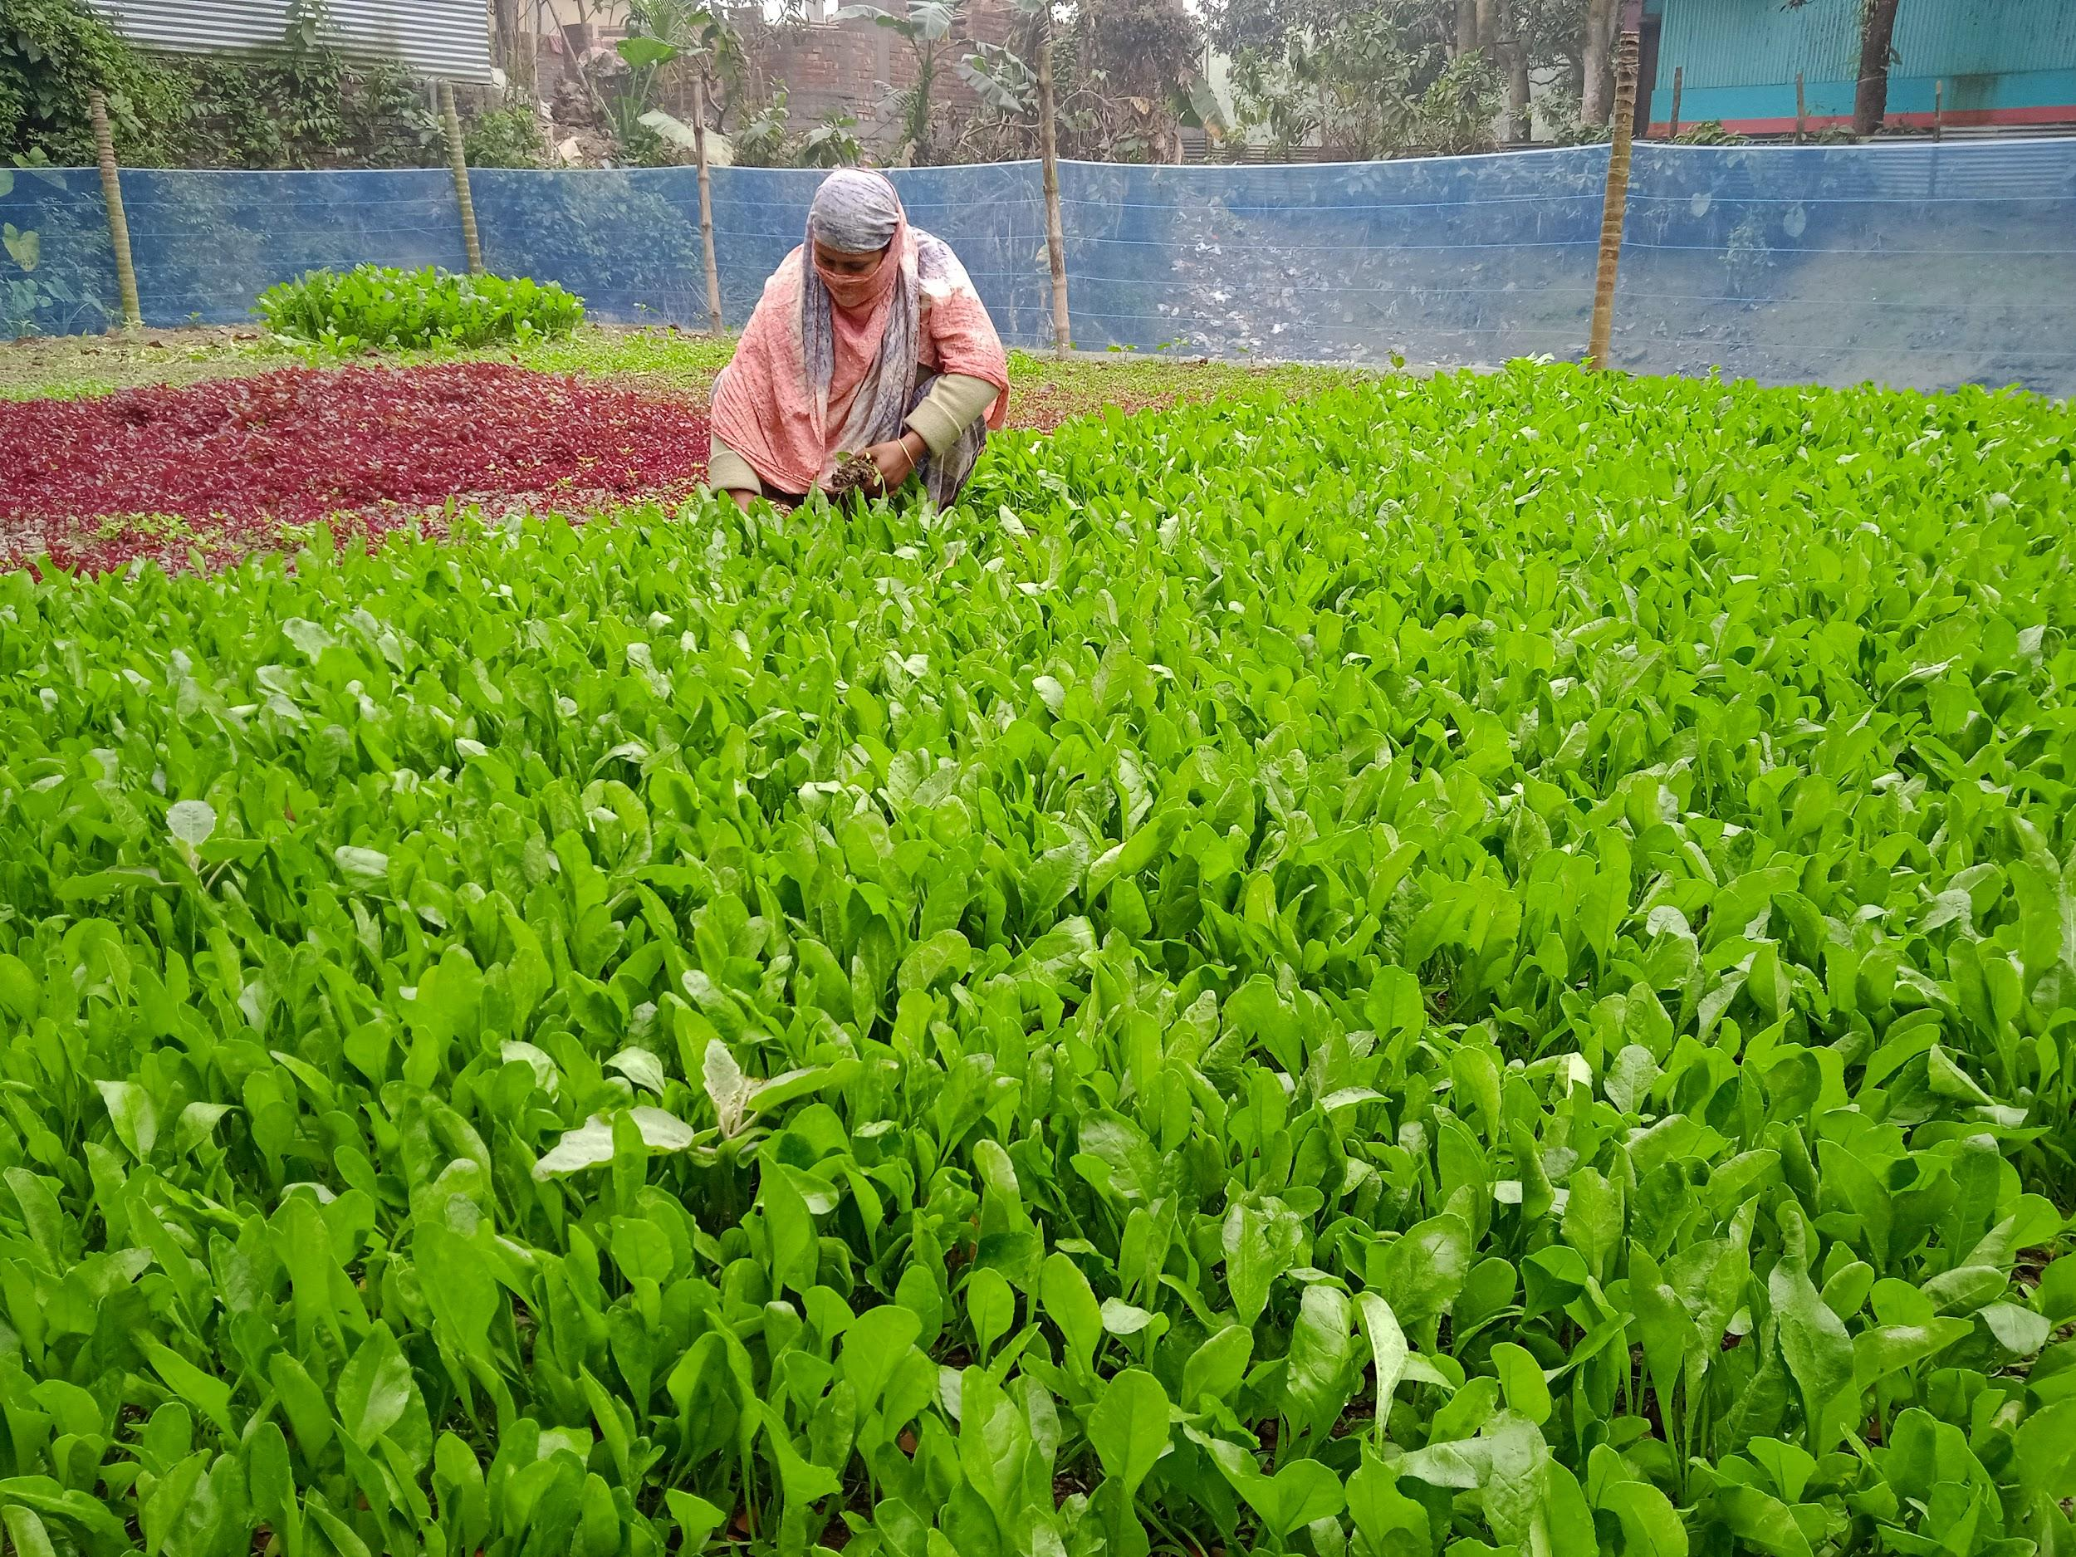

Farmers began sharing their own experiences.

**Yeasir Safat, a young farmer, said, “This project transformed me from an ordinary farmer into an aware and aspiring entrepreneur. Now I am thinking about producing compost myself so that more farmers like me can benefit.”**

**Laboni Khatun, a woman farmer, said, “After using this compost, the colour of the vegetables changed. They are greener and healthier. I get a better price at the market now.”**

**Farmer Hasmot Ali shared, “The soil used to feel lifeless and yields were low. After using the organic compost, the land came back to life. The harvest is better, and the soil feels softer and more fertile.”**

**Md. Shahidul Islam added, “My crops were not growing well and the soil was drying up. After using the vermicompost you introduced, the soil became soft again and yields improved. It feels like the soil is alive once more.”**

Hearing these voices strengthened Rabby’s belief in community driven change. He also began sharing his knowledge widely. From Panchagarh to Barguna, Habiganj to Lalmonirhat, and even at Patuakhali Science and Technology University, Rabby trained more than 160 young people. Each training felt like planting a new seed of hope. Many of the youth he trained have gone on to start their own projects, promoting natural farming methods and eco-friendly food systems in their communities.

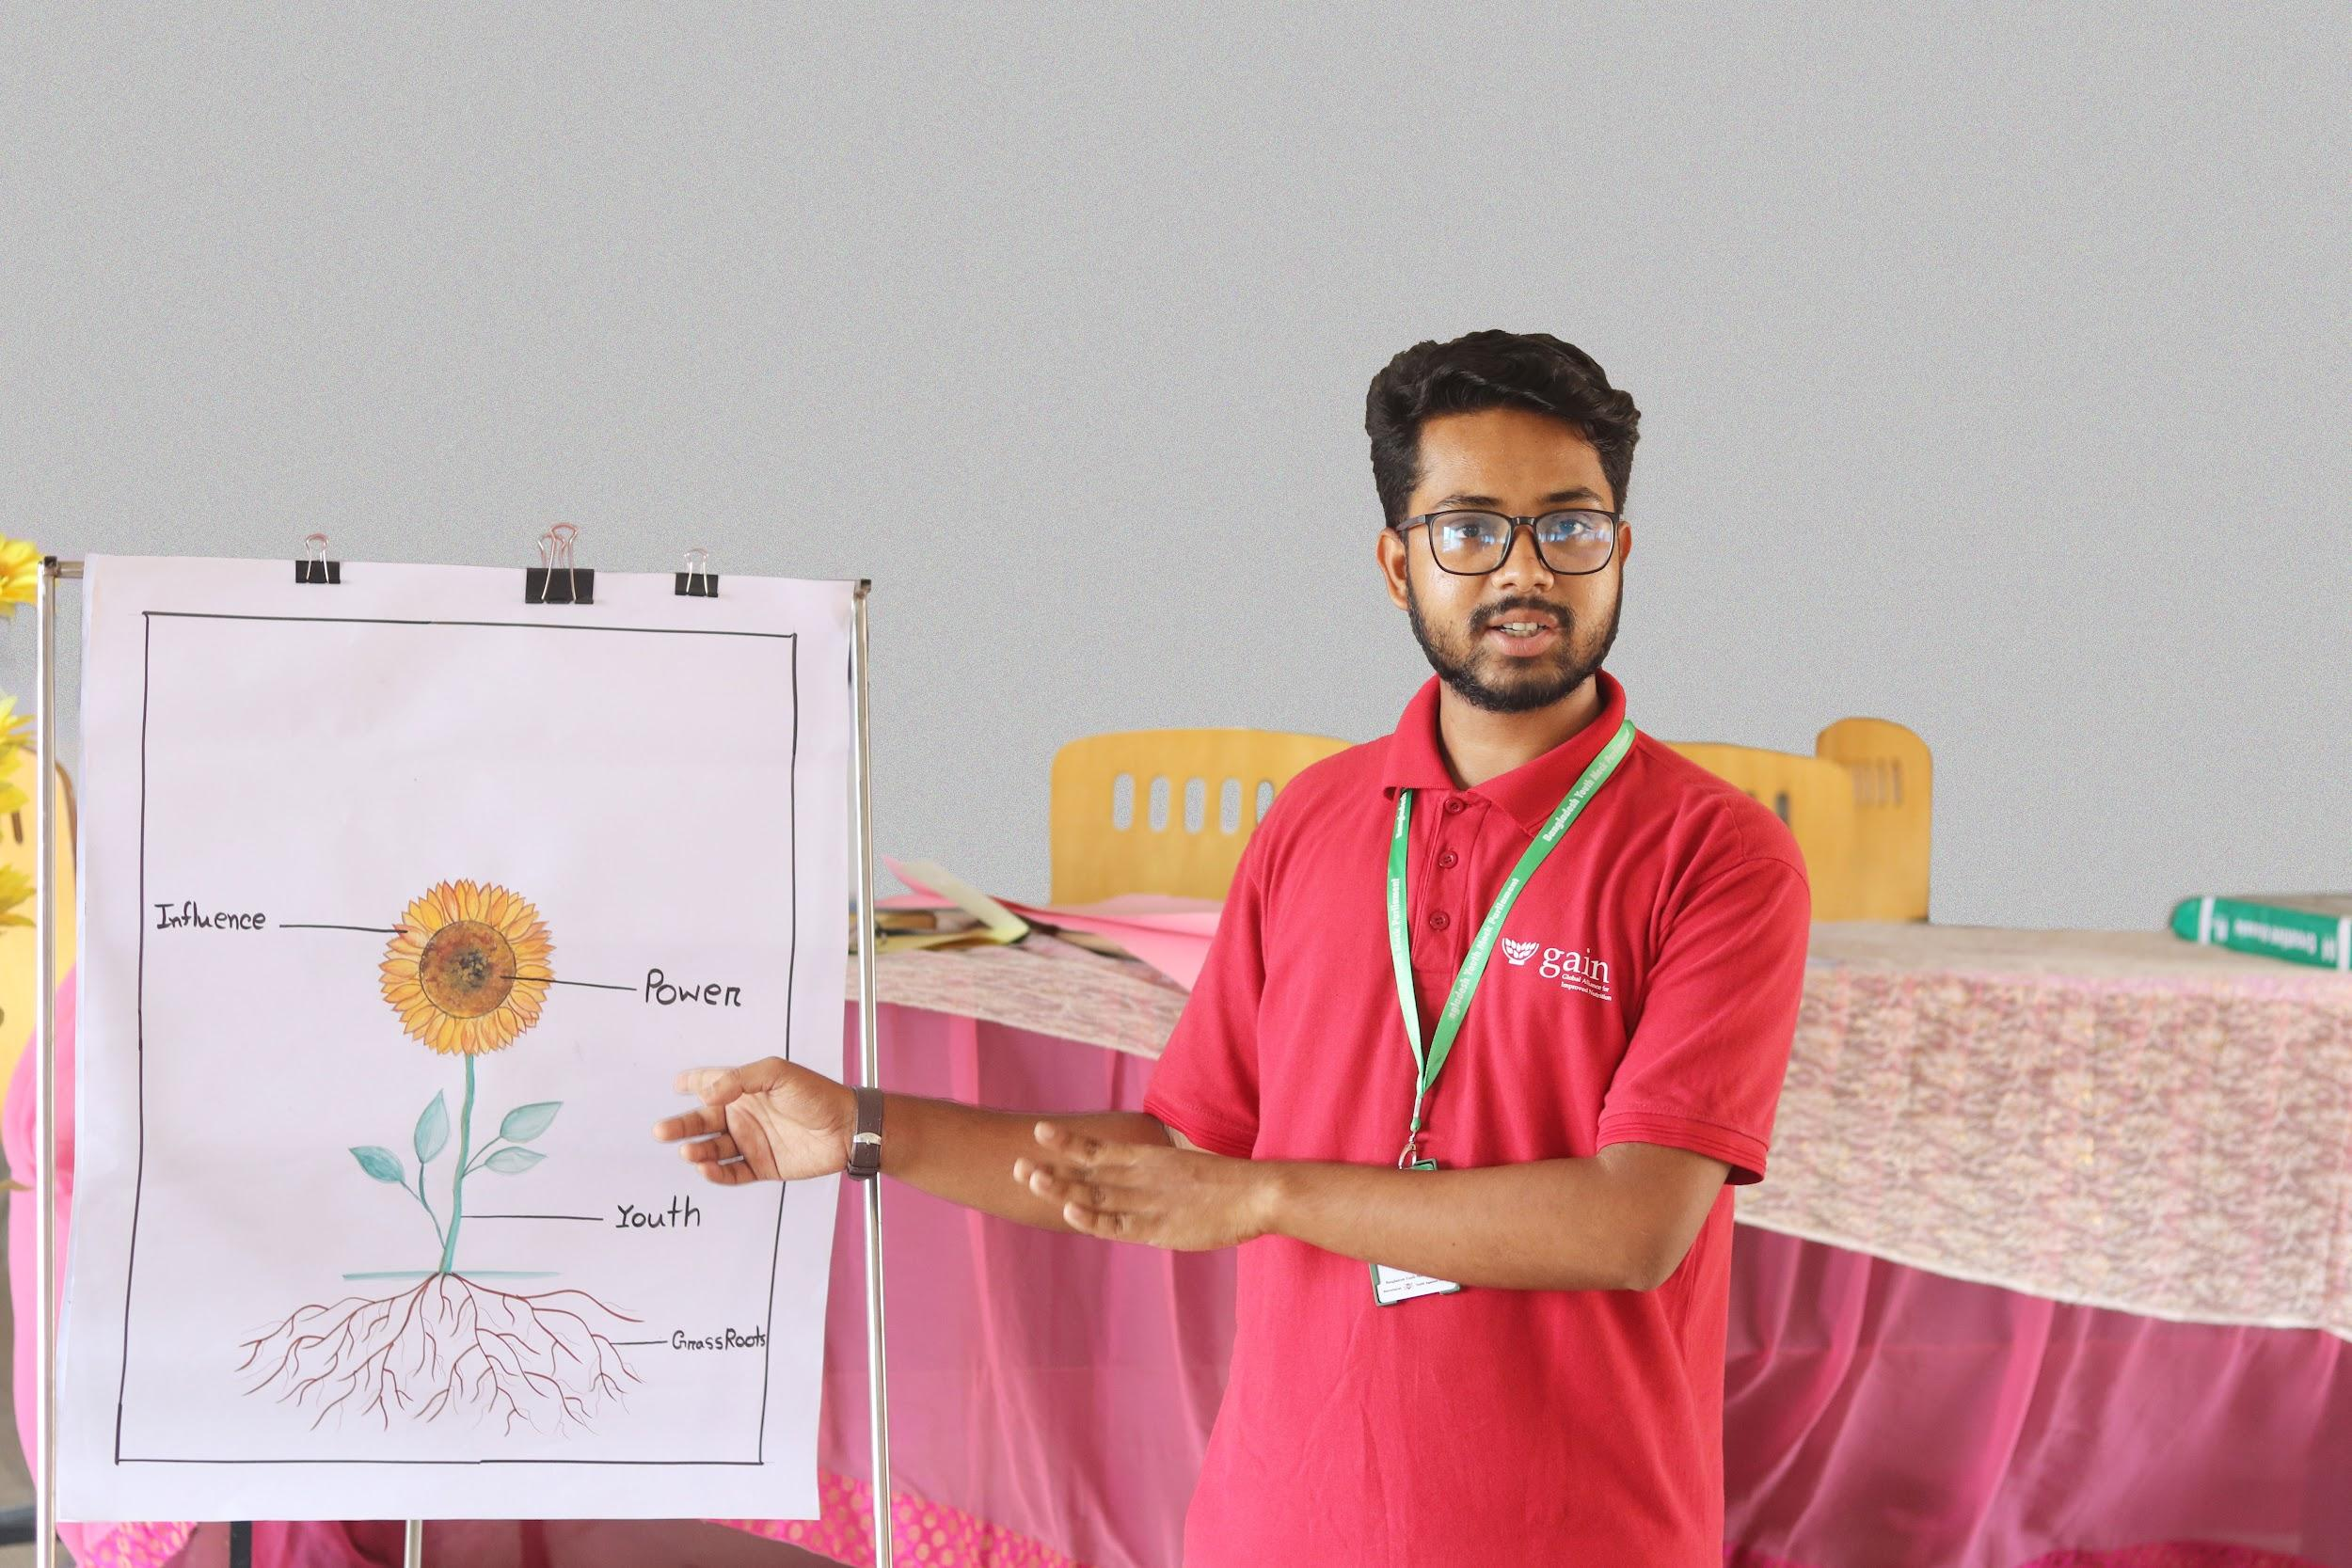 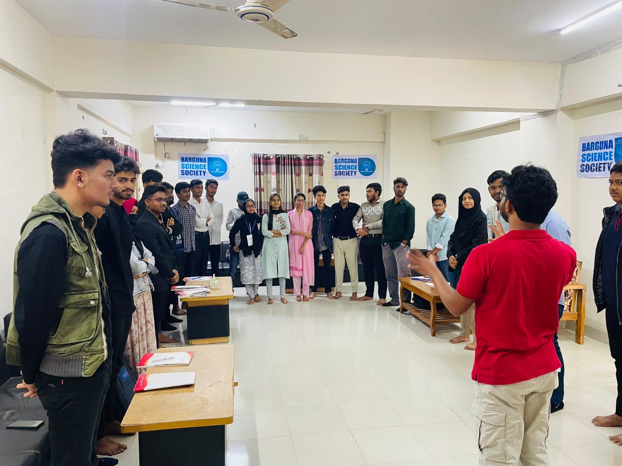

Looking back, Rabby believes the Food Systems Youth Leadership Training was the moment that helped him find clarity and direction. **“The training did not just make me a trainer. It helped me believe that young people can guide change,”** he said. Rabby’s work continues, and the soil he helped restore is only the beginning. Through the commitment of young people like him, more villages are seeing the possibility of healthier land, stronger harvests and sustainable farming practices.

